A Turing Machine with a semi-infinite tape has a left end but no right end. The left end is limited with an end marker.

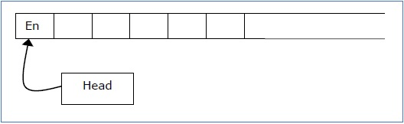

It is a two-track tape −

* **Upper track** − It represents the cells to the right of the initial head position.
* **Lower track** − It represents the cells to the left of the initial head position in reverse order.

The infinite length input string is initially written on the tape in contiguous tape cells.

The machine starts from the initial state **q0** and the head scans from the left end marker ‘End’. In each step, it reads the symbol on the tape under its head. It writes a new symbol on that tape cell and then it moves the head either into left or right one tape cell. A transition function determines the actions to be taken.

It has two special states called **accept state** and **reject state**. If at any point of time it enters into the accepted state, the input is accepted and if it enters into the reject state, the input is rejected by the TM. In some cases, it continues to run infinitely without being accepted or rejected for some certain input symbols.

**Note** − Turing machines with semi-infinite tape are equivalent to standard Turing machines.